Chip back potential is the level which bulk silicon is maintained by on-chip connection, or it is the level to which the chip back must be connected when specifically stated below. If no potential is given the chip back should be isolated.

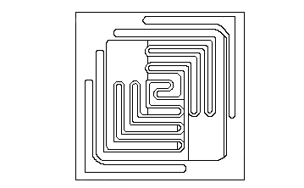
B
E
.024”
.024”

Top Material: Al
Backside Material: NiAuAg
Bond Pad Size: .004” X .004”
Backside Potential: COLLECTOR
Mask Ref: DB078E

APPROVED BY: DK DIE SIZE .024” X .024” DATE: 9/23/21
MFG: FAIRCHILD THICKNESS .007” P/N: BC640TA
DG 10.1.2

Rev B, 7/1

